Computer Language Coding Concepts

Target Classes in a Diagram
The concept of target classes is explained in the article Target Classes. This article only explains their expression in a diagram.

The target object is the last symbol in a string of class redirections and object redirections. But usually it is just class redirections.

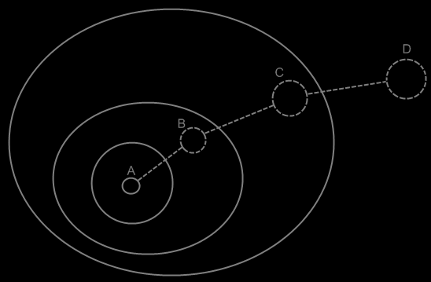

Symbol D is the target class of symbol A, but also of symbol B and symbol C.

Here’s one with an object redirection in it as well:

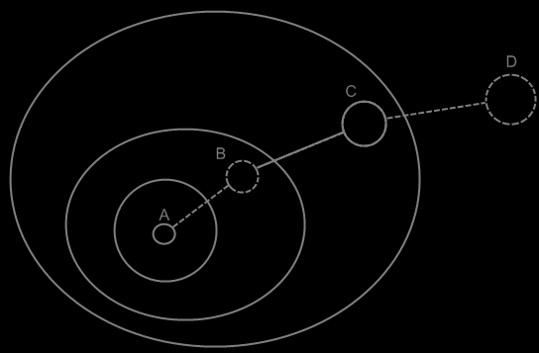

Symbol D is the target class of symbols A, B and C. Symbol B also has a target object, which is symbol C. Symbol C however is not the target object of symbol A. Symbol A specifies its own object.

Remember a special effect in class redirection: even though the target class determines the structure of the object, the default values of the object are set to the values of the first symbol, that is a created object in the class redirection.
If both symbol D and symbol B are created, then when symbol A is created, object A will initially have the values of symbol B, not the values of symbol D.

See also: Target Classes

Author & Copyright: Jan-Joost van Zon Date: May 29, 2008 – May 29, 2008 Location: Oosterhout, The Netherlands Status: Finished

